POSTMAN.com

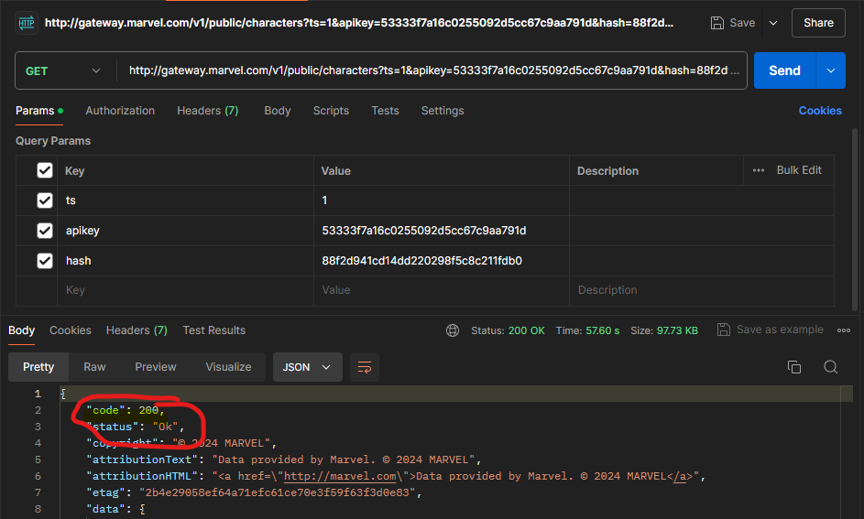

**Criar HASH:**

https://blueimp.github.io/JavaScript-MD5/

https://www.youtube.com/watch?v=kHjnnEBVgw4

https://developer.marvel.com/documentation/authorization

https://developer.marvel.com/account

md5(ts+privateKey+publicKey) -> 88f2d941cd14dd220298f5c8c211fdb0

apkey 53333f7a16c0255092d5cc67c9aa791d

**Teste de API**

https://www.postman.com

https://www.youtube.com/watch?v=TPbkdp3hCcA